**



***Issue of circuits number in a panel***

**Revision: 1.0**

|  |  |  |  |
| --- | --- | --- | --- |
| Date | Revision | Author | Description |
| 2021/6/22 | 1.0 | Lena Liu | Initial creation from team discussions |
|  |  |  |  |
|  |  |  |  |
|  |  |  |  |

**Eaton**

[www.eaton.com/powerquality](http://www.eaton.com/powerquality)

LEGAL NOTICE

Copyright © 2020. Eaton. All rights reserved. The contents of this document constitute valuable proprietary and confidential property of Eaton Corporation and are provided subject to specific obligations of confidentiality set forth in one or more binding legal agreements. Any use of this material is limited strictly to the uses specifically authorized in the applicable license agreement(s) pursuant to which such material has been furnished. Any use or disclosure of all or any part of this material not specifically authorized in writing by Eaton Corporation is strictly prohibited.

**Contact Eaton Support**

For your convenience, Eaton provides support to assist you with questions on installation, operation and troubleshooting. Please contact us at:

[softwareconnectivityts@eaton.com](mailto:softwareconnectivityts@eaton.com)

800-356-5737 option 2, option 5, option 1

# Contents

Contents 3

1. Overview 4

2. Requirement Summary 5

3. Technical Requirements 6

4. Outline Design 7

5. UI Design 8

6. Use Cases 9

7. Implementation Notes 10

# Overview

For new feature requirements, the product team needs to evaluate and review it first. Next teams need to understand the requirement, then estimate the efforts for Design and Implementation.

# Requirement Summary

Support customer specify the number of circuits on Electrical Panel.

[Azbil] Need to add the 48 Circuit panel and show the data on the Dashboard.

[Databank][UBE-646-48444] Support 84 circuits panel.

The circuit panel configuration is incorrect. The PDU supports an 84 panel breakers, I need this PDU configured to support a 84 circuit panel, 42 on the left side (odd), 42 on the rights side (even).

[BNPP][#PCR-374-49065] Circuits number in a panel.

The number of circuits in a panel is not always inherited from the model in the real life. For instance, for custom panel like BUSBAR, the number of circuits is related to the size of room where it’s installed.

In fact, this number is approximatively the number of racks that you can install in a row. And this number depends on the room dimensions and the racks width.

For instance:

In ME11, ME12, BN11, BS11 we need 276 circuits / panel. (92 tri or 276 single phase); In M3, M4, M5, M6 we need 96 circuits / panel (32 tri or 96 single phase) and other panels with 48 circuits (16 tri or 48 single phase)

I have to investigate to know how it’s implemented in other room we manage. And we don’t know what could happen when opening a new room.

VDCX/000-Projects/VDC 6.5.1/Attached Files/Circuits number in a panel - v2.docx

**Existing Feature:**

1. **PDU details page**

* **Create electrical panel/Bulk Creation**
* **Clone electrical panel (with breakers)**
* **Modify electrical panel**
* **Delete electrical panel**
* **Monitor electrical panel (device - Monitor)**
* **Show Circuits table**
* **Show Breakers table**
* **Create circuit breaker/Bulk Creation**
* **Modify circuit breaker**
* **Delete circuit breaker**

1. **Electrical Panel page**

* **Show Circuits table**
* **Show Breakers table**
* **New/Delete Breaker**

**New Feature Requirement:**

# Technical Requirements

As design (before 6.5.1), in the electrical panel monitoring template, each branch circuit has its own current and power attribute for processing data, the attribute name format is "*PDU - P1{circuit #} Power*' or '*PDU - P1{circuit #} Current*', like *PDU - P1C42 Power, PDU - P1C42 Current.* These attributes are fixed. It means if there are 42 circuits, there will be 42 × 2 related attributes. These data points are **Scalar**.

All these branch circuits are listed in a table on PDU page.

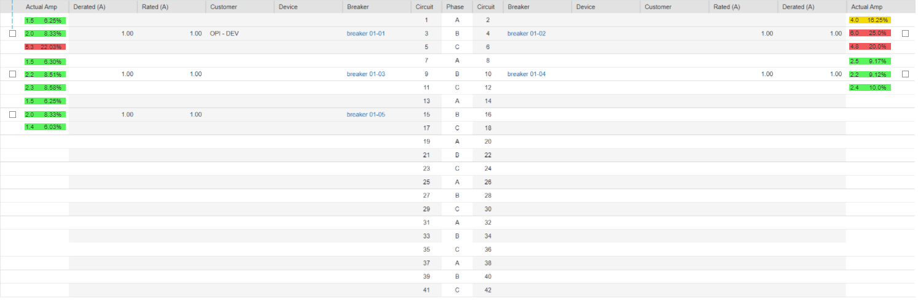

In 6.5.1, we will support users specify the number of circuits on an electrical panel. According this design, if a PDU has 84 circuits, he has to config 48 × 2 monitor data points. So we propose an enhanced solution for this feature. That is, we use **Tubular** to support processing the monitoring attributes on branch circuits. Only2 attributes are used, Active Power, Current.

**What changes we need to do?**

1. Monitoring templates upgrade

* Transform scalar item to tabular item in upgrade script.

1. Trigger definition upgrade
   * Transform triggers defined on these circuit attributes to tabular item + index.
   * Allow user to select specific circuit to add/update trigger.
   * VMS should be able to process tabular + index trigger.
2. Monitoring templates

* Allow user to add tabular for BACNET protocol

1. Modules related PDU power

System should use attribute + index to get circuit value.

* Rack power
* Rack Failover
* Power Path
* PDU Power Reports

# Outline Design

In the version before 6.5.0, we can only support 42 circuit on panel. To Support the panels which max circuit is bigger than 42, we want to change the attributes on panel from scalar to tabular column. For the first 42 circuit, we will still use the same attributes id for storing monitoring data. It will not make any effect on the history data, trend data.

In 6.5.1 upgrade process, it will create new item for tabular and map new item + index = old attribute id. Then all of history data and trend data can be get from old devices. If user create new device or new item, system will generate random id for every circuits.

**Changes on Template**: For new template, we suggest user to use attributes current, active power to monitoring current/power on panel. When we upgrade template. we need to process the following cases.

1. Users add circuit current/power points on template level.

Solution:

Add new tabular items for current, power on template. Creating mapping between old scalar item to new tabular item for every device at backend, remove old scalar items and enable new tabular items on devices.

1. Users add circuit current/power points on device level.

Solution:

Add new tabular items for current, power on device. Creating mapping between old scalar item to new tabular item for every device at backend, remove old scalar items and enable new tabular items on devices.

1. Users add circuit current/power points on both template and device level.

Solution:

Add new tabular items for current, power on device. Creating mapping between old scalar item to new tabular item for every device at backend, remove old scalar items and enable new tabular items on devices.

1. Currently, we only support tabular on SNMP/Modbus, if user uses other protocols to monitor circuit value, we shouldn’t alert critical message to user before start to upgrade to 6.5.1 in precheck.

**Changes on trigger**: we will support user to add trigger on a cell value in 6.5.1 system. When we upgrade triggers, we need to process the following cases.

1. Users add trigger on template level.

Solution:

Update the rule on trigger, replace scalar item with column + index item.

1. Users add trigger on device level.

Solution:

Update the rule on trigger, replace scalar item with column + index item.

1. User add trigger on both template and device level.

Solution:

if the trigger is on template level, then create new trigger and add rule with column + index item. If the trigger is on device level then update the rule on trigger and replace scalar item with column + index item.

**Changes on dashboard**: We will use column + index to get circuit current for system dashboards on panel, if user created customer dashboard, we should upgrade the dashboard definition.

We found databank using BACNET to monitoring panel circuits. We need to add two features to support the requirement. The first one is that allow user to define triggers on column + index. The second one is that allow user to define tubular points for BACNET protocol.

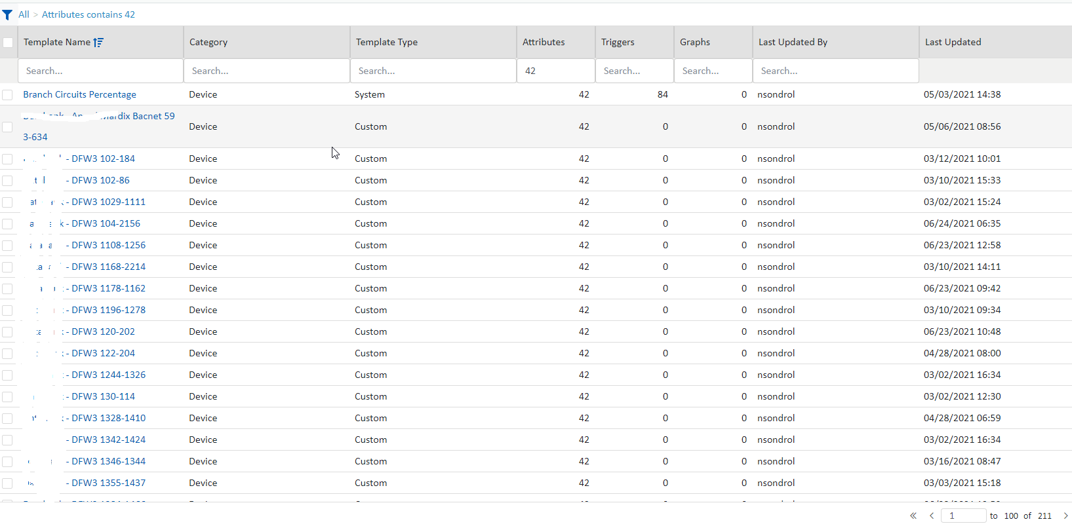

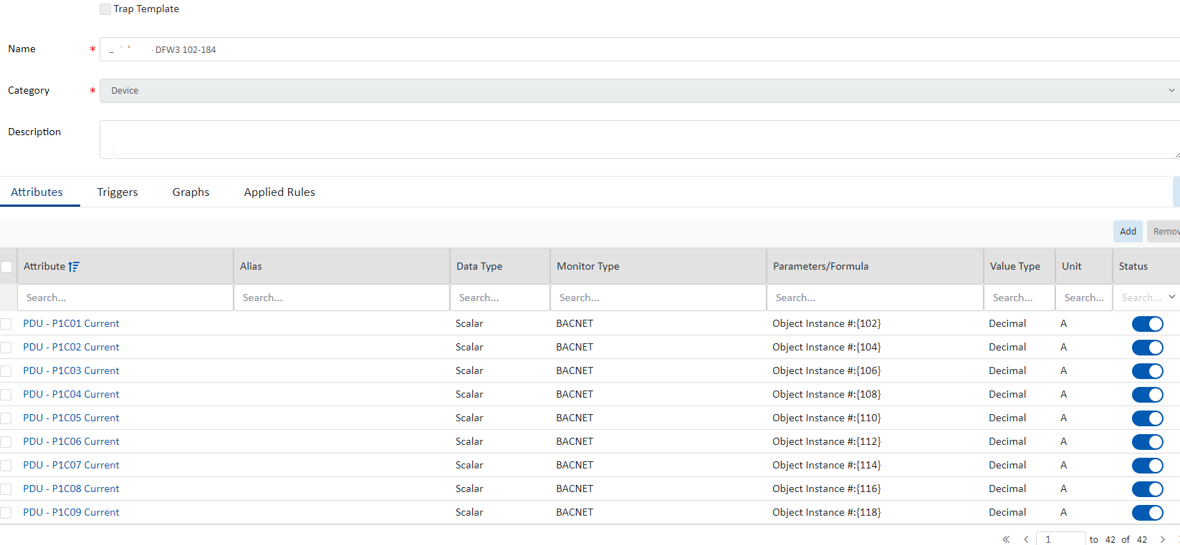

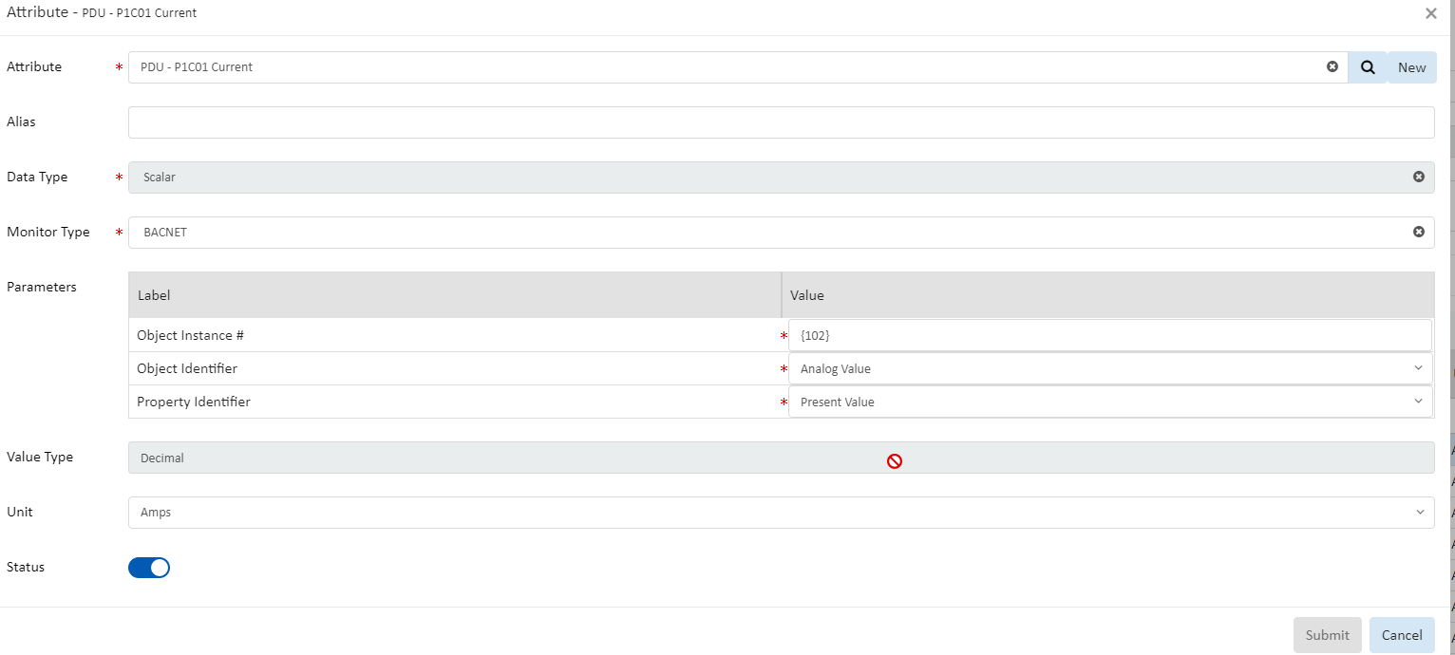

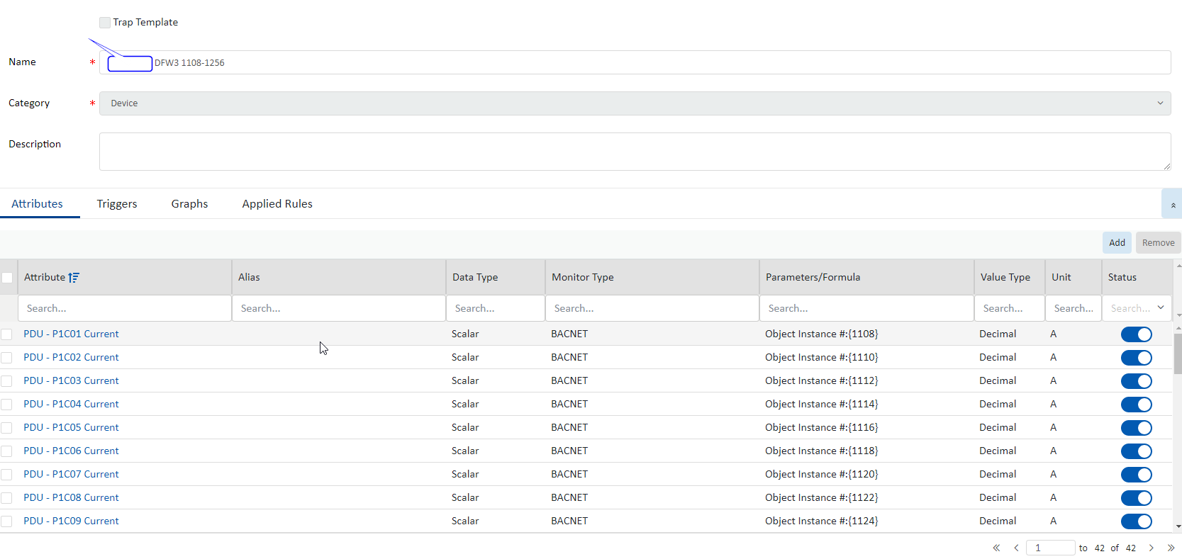

**Outline Diagram:**

**Flow Chart:**

**Database Design:**

# UI Design

svn://10.10.10.26:3709/documents/VDC/VDCX/Devices/UI_Design/PDU (6.5.1)

svn://10.10.10.26:3709/documents/VDC/VDCX/Devices/UI_Design/PDU (6.5.1 Additional)

**UI Components:**

**Create Panel:**

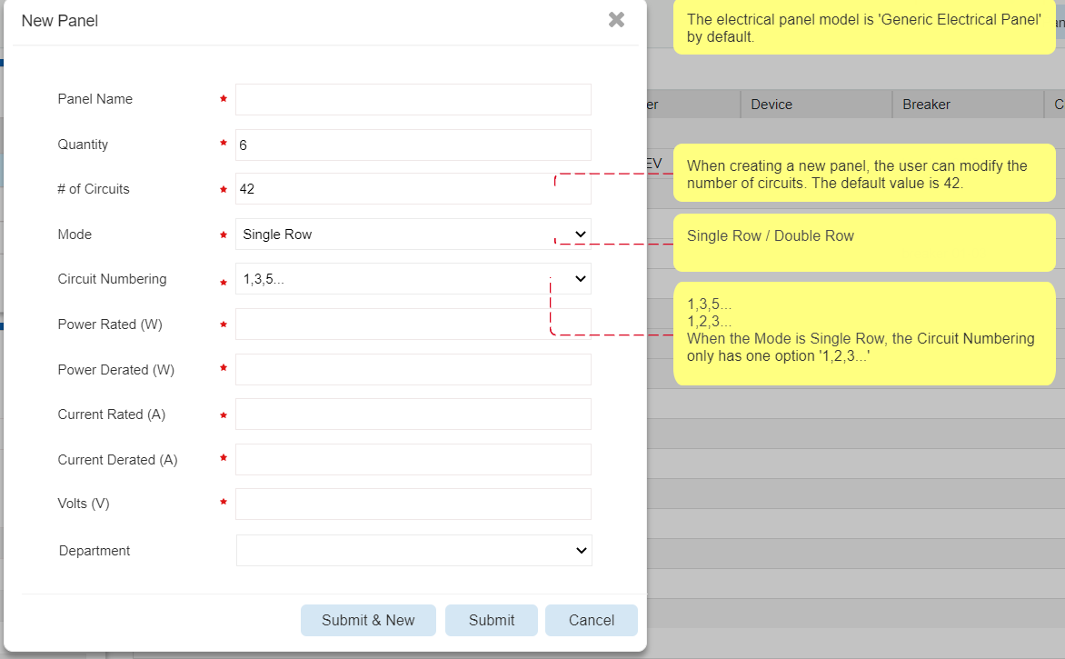

* **Panel Name**
* **Quality**: Default value is 1
* **# of Circuits**: Default value is 42
* **Mode**: Default value is Double Row
* **Circuit Numbering**: Default value is 1.3.5…
* **Power Rated (W)**: Unit is W
* **Power Rated (W) )**: Unit is W
* **Current Rated (A)**: Unit is A
* **Current Rated (A):** Unit is A
* **Volts (V)**: By default, it is inherited from PDU. The user can change it.
* **Department**: It is optional

**Modify Panel:**

Q: Should allow users to modify # of Circuits, Mode and Circuit Numbering?

A: Only allow users modify the # of Circuits.

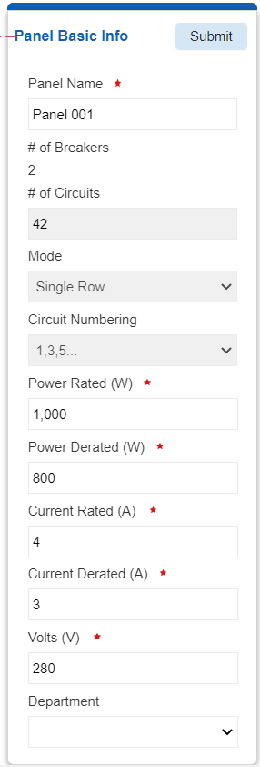

**Create Breaker:**

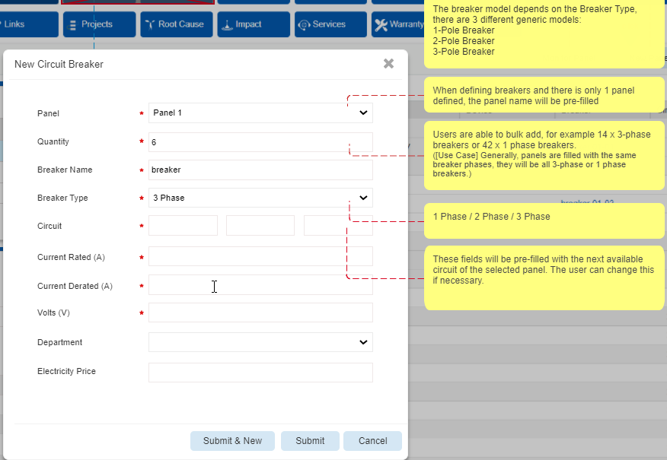

* **Panel**
* **Quality**: Default value is 1
* **Breaker Name**
* **Breaker Type**: Default value is 3 Phase
* **Circuits**: It shows the next available circuits of the selected panel.
* **Current Rated (A)**
* **Current Derated (A**
* **Volts (V)**: By default, it is inherited from the panel. The user can change it
* **Department**
* **Electricity Price**

Notes:

1. Bulk Creation:

If the available circuits which start from the specified circuits are less than the number of breakers to be created, popup a warning message 'The number of available circuits is less than the number of circuits required by the breakers to be created.' require.' and stop submitting.

1. Assist users to avoid creating a 3-phase breaker on an incorrect circuit

In this example of a single-table, it should not be possible to create a 3-phase breaker on circuit 11. I suggest a just warning message, as this could happen, but in 99% of cases it will be a user error in VDC.

When the user is creating a 3-phase breaker, should do the following check:

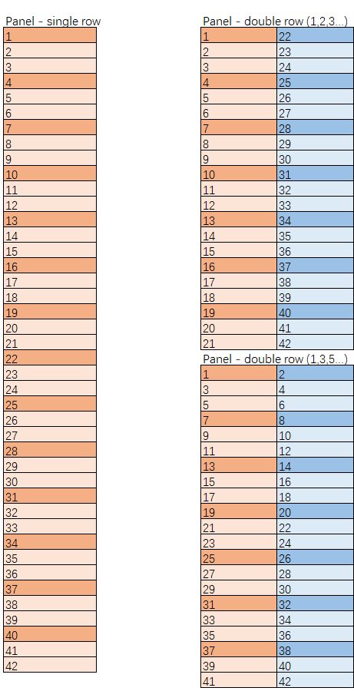

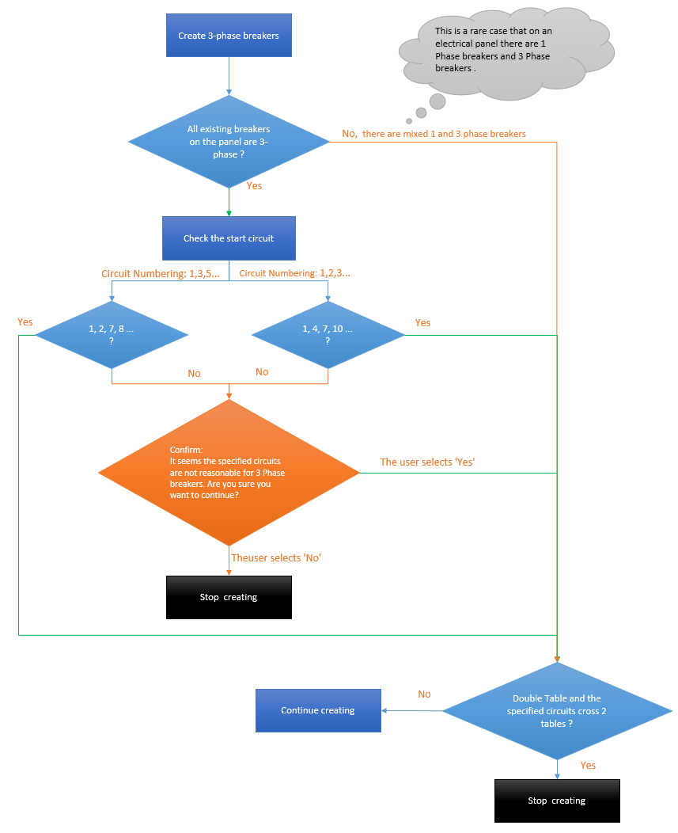

**Modify Breaker:**

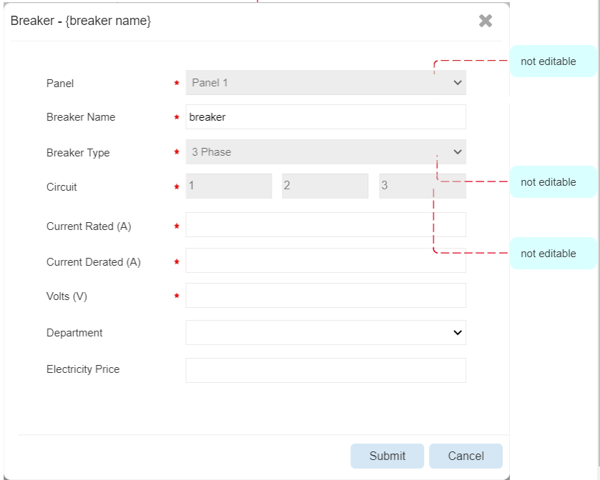

**UI Messages:**

The number of available circuits is less than the number of circuits required by the breakers to be created

It seems the specified circuits are not reasonable for 3 Phase breakers. Are you sure you want to continue?

# Use Cases

[Define use cases for initial test plans of the requirement]

# Implementation Notes

[*What clarifications have been discussed as the feature was developed?* ]

**Effort Estimation:**

|  |  |  |  |  |
| --- | --- | --- | --- | --- |
|  | Task | Efforts (Hours) | Assignee | Comments |
| Front-end | Design |  |  |  |
|  | Development |  |  |  |
|  | **Dev Testing** |  |  |  |
|  | **Total Front-end Estimation** |  |  |  |
| Back-end | Design |  |  |  |
|  | API Development |  |  |  |
|  | DB Development |  |  |  |
|  | **Dev Testing** |  |  |  |
|  | **Total Back-end Estimation** |  |  |  |
| Testing |  |  |  |  |
| Bug Fixing |  |  |  |  |
|  | Total |  |  |  |
|  |  |  |  |  |
|  |  |  |  |  |